Heptameter

📏 What is Heptameter
# Source: AI Source: Provided by: [Data Path: Persons Table -> ID Column: 1, Name_En Column: Motasem Essam] -> From: [Chatgpt (GPT-4-turbo)] on [8/2/2025]
Heptameter is a poetic meter with seven metrical feet per line. In English poetry, it’s most often seen in iambic heptameter, commonly known as a fourteeners because it typically has 14 syllables per line (7 × 2 syllables). It’s rhythmic and often narrative in tone.

🧱 Structure
# Source: AI Source: Provided by: [Data Path: Persons Table -> ID Column: 1, Name_En Column: Motasem Essam] -> From: [Chatgpt (GPT-4-turbo)] on [8/2/2025]
- 7 metrical feet per line
- Most commonly in:
  - Iambic heptameter (de DUM × 7)
  - Occasionally in anapestic or trochaic forms
- A full line may be split into two hemistichs (half-lines) with a caesura (pause) in the middle

📝 Example (Iambic Heptameter)
# Source: AI Source: Provided by: [Data Path: Persons Table -> ID Column: 1, Name_En Column: Motasem Essam] -> From: [Chatgpt (GPT-4-turbo)] on [8/2/2025]
He only says, ‘Good fences make good neighbors,’ is his claim
— Robert Frost (modified to 14 syllables)
For man’s grim fate and heaven’s will, the stars above were cast
— Example line in iambic heptameter (14 syllables)

🧬 Variants
# Source: AI Source: Provided by: [Data Path: Persons Table -> ID Column: 1, Name_En Column: Motasem Essam] -> From: [Chatgpt (GPT-4-turbo)] on [8/2/2025]
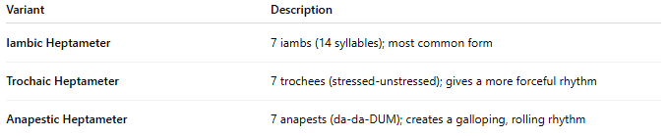
Variant | Description
Iambic Heptameter | 7 iambs (14 syllables); most common form
Trochaic Heptameter | 7 trochees (stressed-unstressed); gives a more forceful rhythm
Anapestic Heptameter | 7 anapests (da-da-DUM); creates a galloping, rolling rhythm

🎭 Effect in Poetry
# Source: AI Source: Provided by: [Data Path: Persons Table -> ID Column: 1, Name_En Column: Motasem Essam] -> From: [Chatgpt (GPT-4-turbo)] on [8/2/2025]
- Creates a narrative, flowing rhythm
- Good for ballads, folk tales, and dialogue poems
- Often feels musical or chant-like
- Can be intense or breathless due to line length

📚 Where It's Found
# Source: AI Source: Provided by: [Data Path: Persons Table -> ID Column: 1, Name_En Column: Motasem Essam] -> From: [Chatgpt (GPT-4-turbo)] on [8/2/2025]
Heptameter is found in:
- Ballad meter variants and hymns
- Narrative verse and storytelling poetry
- Elizabethan drama and early English poetry
- Spoken word poetry for dramatic effect
- Song lyrics with elongated lines

